MANUAL  Application form  Call: 2 December 2019 | 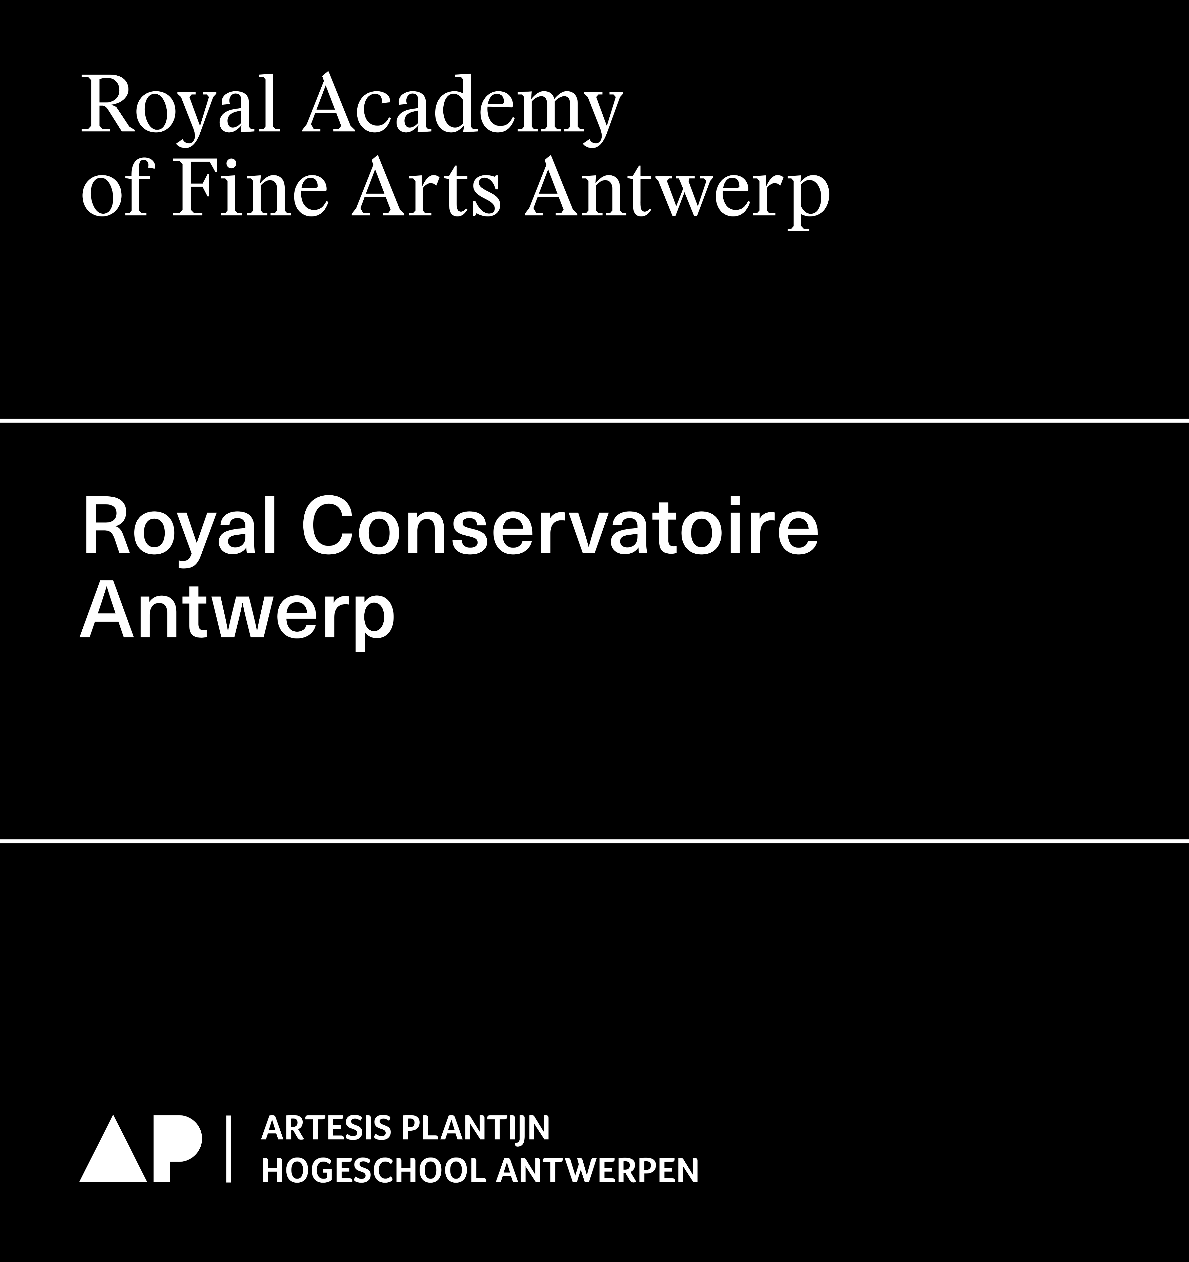
Final date of submission 2 December 2019 at 12.00 p.m. (noon)
Way of submission This application form in word + PDF
Submit to RAFA: Els DE BRUYN - 03 213 71 20 - els.debruyn@ap.be
RCA: Kevin VOETS - 03 244 18 27 - kevin.voets@ap.be

Do you have questions, or do you want a research co-ordinator or a research group to give feedback on your research proposal? Please inform them in time. Make sure you have a meeting with the research co-ordinator before October and send him/her your research proposal at least three weeks before the deadline of 2 December (11 November) so she/he has the time to take a look at your proposal.

This manual assists in completing the application forms for research projects. Some general important terms are clarified. Only take into account the requested information in your application form, since the list of terms in this manual could be more elaborate than your application form.

General advice for the application of research proposals
- A research proposal gives an idea of the subject or the problem you want to study, and how you will carry out your research.
- Make sure that your proposal is specific and clear. What exactly do you want to investigate? Do not skip steps of the thinking process. Define the important concepts of your research in an accurate and complete way.
- Make sure that your proposal is feasable within the given research duration. Are there no unrealistic promises made?
- Is your research challenging and innovative? Has your research been performed elsewhere? Does it increase our (general or specific) knowledge?
- To what extent is your research relevant for the Higher Arts Education in general, and for RCA or RAFA in particular? To what extent does it contribute to the enrichment of existing research and/or research groups?
- To what extent is your research relevant for artistic and societal purposes?
- Is the intended output (specific realisations) formulated in a detailed way?
- A good research proposal tells a coherent story. Don’t you make unnecessary diversions? Is your research outlined well? What will you investigate, and what not?

Specification of terms and concepts
Research project title
Formulate the title clearly and condensed.
Requested budget
Indicate the total requested budget (one amount). The total of staff, operational and investments. If the project is accepted, this project budget will be the guideline. In other words: accepted budgets per year can, in principle, no longer be modified or altered after submission of the project proposals.
Start date
Indicate the start date of the project (if accepted). The research project could start at the earliest on 16 September 2020.
End date
Indicate the end date of the research project (if accepted). Take the maximal duration of your research proposal into account: start project = 1 year; one-year research project = 1 year; two-year research project = 2 years.
Promotor
A researcher operates under the artistic supervision of a promotor of the Schools of Arts (RCA or RAFA). This promotor has, beside his/her statute, expertise in the domain of the proposed research. It is important that the promotor is able to supervise the project in principle during the whole intended period. Only members of the Schools of Arts of AP Hogeschool qualify as a promotor.

A promoter can submit a maximum of four application forms per call over all types of projects (ut infra). If more than four application forms are submitted by the same promoter, the research council decides on which four application forms are accepted as being admissible.
Subject
Define briefly which subject(s) you will investigate. What is the angle and/or problem that is related to your subject?
Research question
Propose one or more specific, clear research questions which your research will attempt to answer. These questions ought to be challenging and at the same feasible within the given duration and available resources.
Theoretic and artistic framework
Give an overview of the theoretic and artistic framework with references to relevant sources. This framework describes the context of your research and artistic practice in relation to other practices and related research. To which existent research is your research connected? What is already known about your subject in the literature/theory and/or artistic practices?
Methodology
Clarify which research methods you will use or develop and why. Which data or material will be collected/researched? How will they be collected and analysed?
Key words
Give up three key words or combinations of words that emcompass the focus of the research.
List of Flemish research disciplines
Give at least one and maximum three codes. The codes were created at the Flemish government level as a system to classify research based on disciplines. Reporting to the Flemish government about research projects requires the indication of at least one code. Research projects, especially multidisciplinary research projects, take place within different disciplines, therefore the possibility to give up to 3 codes.
Reporting and ouput
Clarify in which way and via which instruments your research project will be disseminated. Think of both the artistic output (e.g. performance, lecture,…) and other output (e.g. research report, paper, article in magazine, symposium, lecture,…). Be as precise and detailed as possible.

All output of research (both textual and non-textual output) must be registered in the database of the academic bibliography of the AP University College. The researcher takes the initiative to register via this form. Based on the registered output, your research project will be evaluated by the Research Council.
Planning of the project
What steps will you take conducting your research? Think of, for example, the theoretic and artistic framework, methodology, data collection, conducting interviews, structure of composition/performance,…
Bibliography / sources
Supply an overview (through the text or in list form) of the most important sources you will use in your research. Contact the research co-ordinators to receive a manual for a bibliography.
Intended outcomes and relevance
To what extent is your research relevant for the supporting research group, the Higher Art Education and society? Which new insights will your research, ideally, provide?
FTE (full-time equivalent)
FTE stands for full-time equivalent. It is a unit between 0 and 1 that expresses the proportion of the personnel post. A full working week of 38 hours (or 40 hours in some organisations) is 1 FTE. A function of, for example, 0,6 FTE corresponds to 22,8 hours a week (0,6 x 38 hours).
Staff costs
Staff costs are the wage costs applied for staff of a research project (researcher, executor,…). Promotors and other supervisors of research projects are usually not paid for their guidance and therefore those costs should not be budgeted in the research proposal.
Operational costs
Operational costs include those costs necessary to realize the daily operation of a research project. Eg. transport costs, travel expenses, accommodation costs, printing costs, organisation costs, use of halls, logistics, etc. Concerning use of halls and technical assistance in the RCA: see document ‘Informatie begroting & planning PRODUCTIEKOSTEN’.
Investments
Investments are the costs for investments of sustainable goods in order to realize a research project. Eg. costs for a laptop, microphone, hard disk, etc.

