PhD Fellowship  Application Form  Call for Applications: Deadline March 17, 2025  Start Date: September 2025  Duration: 48 months | 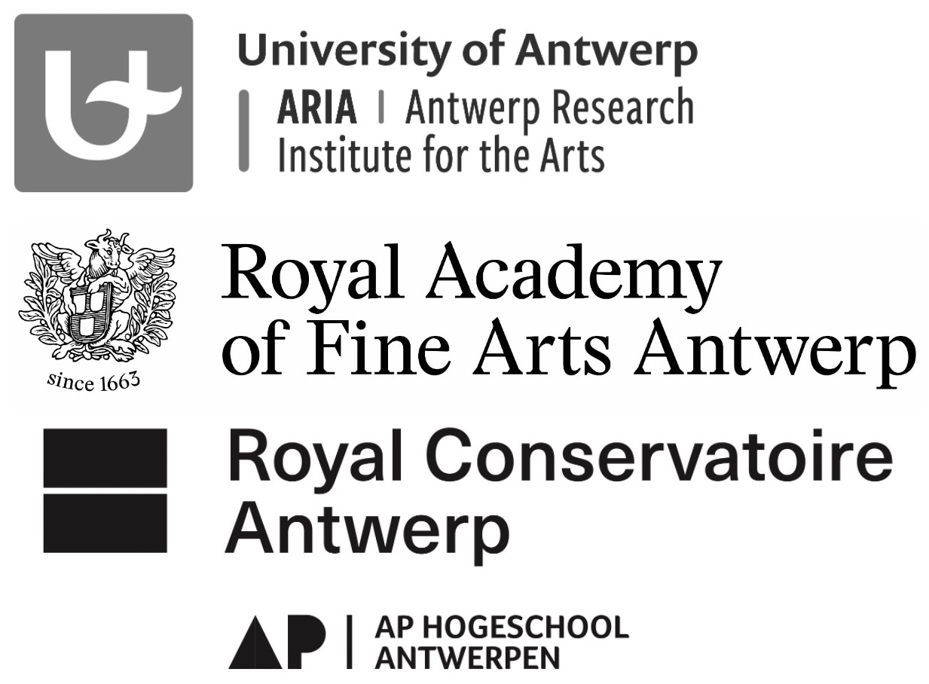
Submission Deadline: March 17, 2025, at 12 PM (noon)
Submission Method: One PDF file via email

Submit to:
Royal Academy of Fine Arts Antwerp: ELS DE BRUYN – els.debruyn@ap.be

- The PhD fellowships at the Royal Academy of Fine Arts Antwerp aim to fund a PhD candidate in the arts for a period of four years with a part-time mandate (55% assignment) as a researcher.
- The research should align with, co-endorse and further develop the mission/vision of the Royal Academy of Fine Arts Antwerp, and preferably also connect to one of the four research groups at the Royal Academy.

- Application Preparation Timeline & Formal Requirements

- Applications submitted by March 17th 2025 (12h) are expected to be guided by two supervisors (from Antwerp University and the Royal Academy of Fine Arts Antwerp), and must meet all formal requirements. To ensure a smooth process, follow the steps and timeline below:

By February 1, 2025 at the latest, you should have found one supervisor from the University of Antwerp and one from the School of Arts willing to support your candidacy and research proposal.

From the Royal Academy, any staff member with relevant expertise can act as supervisor. Please note that the staff member can act as supervisor for the entire duration of the research (48 months). A maximum of two application files can be submitted per staff member in order to guarantee qualitative guidance to the candidate. An overview of the staff members can be found here: personnel | AP School of Arts

From the University of Antwerp, anyone with a ZAP (Independent Academic Personnel) status can act as a supervisor. It is best to search within the faculty where you expect relevant expertise. All information can be found on the UA website.

You submit your application no later than March 17, 2025 - 12h. A signature of your supervisors (University of Antwerp and Royal Academy of Fine Arts Antwerp) is required upon submission so that your application is formally in order. It is also recommended that the coordinator of the research group to which your proposal is attached, co-sign the application.
Identification of the Research Project

Applicant (Principal Researcher):
Name, Email Address
Title of the Research Project:
Dutch & English
Provide the final project title. This title will be used for all future references, including in the Flanders Research Information System (FRIS).
Start Date | September 2025
End Date | September 2029
Three Keywords
Flanders Research Discipline Codes
Min 3 relevant codes
Supervisor(s) School of Arts:
Name, e-mailadress
Supervisor(s) Antwerp University:
Name, e-mailadress
Primary Research Group  Indicate the primary research group supporting your project. | Royal Academy of Fine Arts Antwerp  ArchiVolt  Art&Ecology  MAXLab  Thinking Tools
Secundary Research Group(s) (OPTIONAL)  If your project is also supported by another research group apart from the primary researchgroup, indicate it here. You can choose a secondary research group from both the Academy and the Conservatoire. | Royal Academy of Fine Arts Antwerp  ArchiVolt  Art&Ecology  MAXLab  Thinking Tools  Royal Conservatoire Antwerp  CORPoREAL  CREATIE  Labo XIX-XX  UP - Performance in Perspective

Lay Summary of the Research Project
Provide a concise summary of the research project in lay terms, in both Dutch and English.

Concise summary of the research project in lay terms - DUTCH
Max 1500 characters (including space)

Concise summary of the research project in lay terms - ENGLISH
Max 1500 characters (including spaces)

Detailed Description of the Research Project

Project Description
Maximum 10,000 characters (including spaces; excluding source references and other references)
Must include: subject; research questions; theoretical and artistic context and state of the arts of the research domain; methodology; reporting and output, relevant sources and / or literature

Description of the proposed output of the research project
Maximum 1500 characters (including spaces)

Project Timeline
Maximum 2500 characters (including spaces)
Describe the research plan, including phased progress related to the research questions and methodology, and outline key activities.

Relevance of the Research Project

Relevance to Education (nexus) and Research at the Academy/Conservatoire
Maximum 2500 characters (including spaces)
Substantiate the relevance and added value of the research for the Academy and specifically for the research groups. Be as concrete and specific as possible (e.g.: letter of recommendation, list of concrete contacts and appointments, ...).

Relevance to Society and the Arts Field
Maximum 2500 characters (including spaces)
Situate the research project in the societal and artistic context, referencing existing research and research groups outside the Schools of Arts and within international forums. Be as specific as possible.

Project Team

Composition of project team
List all research collaborators involved in the PHD project, indicating their role within the research and the corresponding time investment in FTEs. Also list all collaborations, both within education and beyond. All collaborators and partners listed were contacted and gave their consent.

 | Supervisors
Schools of Arts ( Royal Academy of Fine Arts):
Name, email, training/ degree of supervisor
University
Name, email, training/ degree of supervisor
Research Staff Royal Academy of Fine Arts/Royal Conservatoire/AP University College
(actual research activities)
Name and School of Arts |  | Role within the research project |  | Workload in FTE | Period
Collaborations with Other Universities/Colleges
Highschool / University |  |  | Name and e-mailadress |  | Role within the research project
Collaborations with External Organizations
Organisation |  |  | Name and e-mailadress |  | Role within the research project

Relevant Expertise of Team Members and partners
Maximum 7500 characters (including spaces)
Justify the choice of the project team. For the applicant(s), promoter(s), researchers involved and external partners, provide an overview of already completed and/or ongoing (research) projects or other experiences relevant to this project application. If implementers or partners are not yet known, indicate what profiles will be sought to fill those positions.

Budget

Personnel Costs
For four academic years, the doctoral student will receive a paid 55% appointment as a contract researcher. The annual contract extension is subject to a positive assessment of the progress report.
*50% research assignment, 5% assignment nexus research-education - filling in by mutual agreement after project approva).
*Check in advance whether you are in a position to be contractually employed by a Belgian employer (especially the AP University College).

Operational costs
Maximum 2500 characters (including spaces)
In addition, the doctorandus/-a can have working funds and resources for training:
- 1000 euro annual working funds from the School of Arts;
- 1500 euro from the Doctoral School of the Antwerp University, to be spent as training credits (for the entire duration of the doctoral trajectory) for PhD candidate following the full doctoral training;
- 3000 euro operating funds from the Antwerp University (for the entire duration of the doctoral pathway), only for PhD candidate who do not have additional funding (such as FWO).
One-off €1000 from Antwerp University , to be spent only on the organization of a research seminar.
Briefly describe how the use of operating funds corresponds to the planning per year.

Utilization of operating funds in terms of project realization and planning over 48 months:

External funding
If funds have also been applied for or acquired through other sources for this research project, please indicate this in the table below.

Funding source* | Requested amount | Obtained amount | Spending year | Cost type**
* Funding source: European project funds, FWO project funds, VLAIO project funds, project grants, co-production contribution, ...
** Cost type: personnel costs, operating costs or investments

If additional and/or alternative funding will be requested for this research project, please indicate this in the chart below.

Funding source* | Requested amount | Submission deadline | Cost type**
* Funding source: European project funds, FWO project funds, VLAIO project funds, project grants, co-production contribution, ...
** Cost type: personnel costs, operating costs or investments

Declaration by the Applicant(s)
☐ I confirm that I hold a relevant Master's degree (or equivalent) in (Fine) Arts

☐ I confirm that I am in a position to be contractually employed by the Royal Academy of Fine Arts Antwerp (AP Hogeschool) and committed to a 55% contractual employment for 4 academic years with effect from 15 September 2025.

☐ I declare that I have read and will comply with the deontological code of Schools of Arts in the context of this research project.

☐ In line with the ALLEA deontological code, it is desirable that an ethics committee considers this research project.

Attachments

Voeg als bijlage je artistiek CV en portfolio (mogelijk met link naar je website of online portfolio) toe (samen met dit formulier in 1 PDF-bestand, maximum 4 pagina’s).

Signatures

Research coordination will also accept an e-mail declaration from the supervisor and the chair/coordinator of a research group, possibly replacing signatures.
If external parties are mentioned in the dossier (as part of a collaboration or advisory role), please attach a letter/email confirming this.

Chair/coordinator of research group: Supervisor School of Arts:

Supervisor Antwerp University

